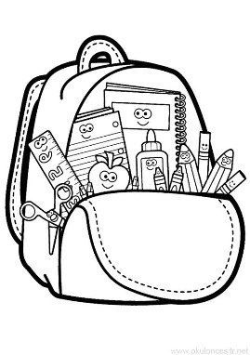

**School Supply List**

Each family will need to supply the following items for their child:

* A backpack or tote bag.
* A lunch box and reusable water bottle.
* A complete change of clothing, including underwear and socks, packaged in a gallon sized freezer bag and labeled with your child’s name.
* Diapers/Pull Ups and changing supplies if you child is not toilet trained.
* 2 rolls of paper towels
* 1 box tissues
* 1 container disinfecting wipes
* All Twos – 2 hand soap dispensers or one larger soap refill
* All Threes – one box quart size freezer bags
* All Fours – one box gallon size freezer bags

Due to space limitations, we may ask each family to provide additional supplies after the Christmas break if needed.